Experiment 2

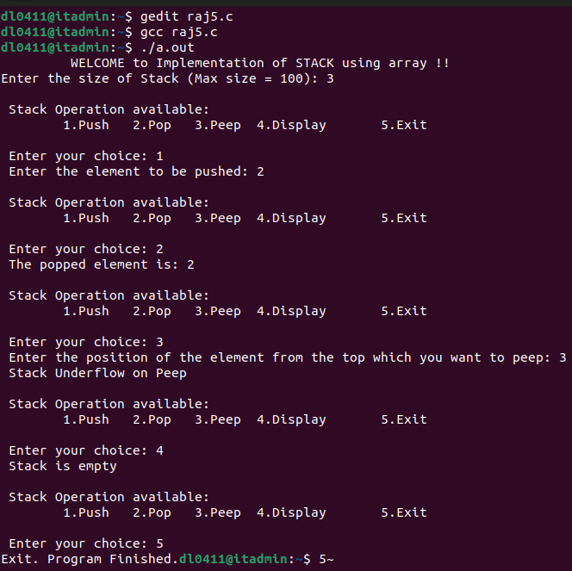
#include <stdio.h>
int STK[100], TOP = -1, i, n, x, choice;
void Push();
void Pop();
void Peep();#include <stdio.h>
int STK[100], TOP = -1, i, n, x, choice;
void Push();
void Pop();
void Peep();
void Display();
int main()
{
printf("\t WELCOME to Implementation of STACK using array !! \n");
printf("Enter the size of Stack (Max size = 100): ");
scanf("%d", &n);

do
{
printf("\n Stack Operation available: \n");
printf("\t1.Push\t 2.Pop\t 3.Peep\t 4.Display\t 5.Exit \n");
printf("\n Enter your choice: ");
scanf("%d", &choice);
switch (choice)
{
case 1:
Push();
break;
case 2:
Pop();
break;
case 3:
Peep();
break;
case 4:
Display();
break;
case 5:
printf("Exit. Program Finished.");
break;
default:
printf("Invalid Option. \n");
}
} while (choice != 5);
return 0;
}

void Push()
{
if (TOP >= n - 1)
{
printf(" Stack Overflow \n");
}
else
{
printf(" Enter the element to be pushed: ");
scanf("%d", &x);
TOP++;
STK[TOP] = x;
}
}

void Pop()
{
if (TOP < 0)
{
printf(" Stack Underflow \n");
}
else
{
printf(" The popped element is: %d \n", STK[TOP]);
TOP--;
}
}

void Peep()
{
printf(" Enter the position of the element from the top which you want to peep: ");
scanf("%d", &i);
if (TOP - i + 1 < 0)
{
printf(" Stack Underflow on Peep \n");
}
else
{
printf(" The %d element from the top is: %d \n", i, STK[TOP - i + 1]);
}
}

void Display()
{
if (TOP < 0)
{
printf(" Stack is empty \n");
}
else
{
printf(" The element in the stack are:");
for (i = TOP; i > -1; i--)
{
printf("\n %d \n", STK[i]);

}
}
}
void Display();
int main()
{
printf("\t WELCOME to Implementation of STACK using array !! \n");
printf("Enter the size of Stack (Max size = 100): ");
scanf("%d", &n);

do
{
printf("\n Stack Operation available: \n");
printf("\t1.Push\t 2.Pop\t 3.Peep\t 4.Display\t 5.Exit \n");
printf("\n Enter your choice: ");
scanf("%d", &choice);
switch (choice)
{
case 1:
Push();
break;
case 2:
Pop();
break;
case 3:
Peep();
break;
case 4:
Display();
break;
case 5:
printf("Exit. Program Finished.");
break;
default:
printf("Invalid Option. \n");
}
} while (choice != 5);
return 0;
}

void Push()
{
if (TOP >= n - 1)
{
printf(" Stack Overflow \n");
}
else
{
printf(" Enter the element to be pushed: ");
scanf("%d", &x);
TOP++;
STK[TOP] = x;
}
}

void Pop()
{
if (TOP < 0)
{
printf(" Stack Underflow \n");
}
else
{
printf(" The popped element is: %d \n", STK[TOP]);
TOP--;
}
}

void Peep()
{
printf(" Enter the position of the element from the top which you want to peep: ");
scanf("%d", &i);
if (TOP - i + 1 < 0)
{
printf(" Stack Underflow on Peep \n");
}
else
{
printf(" The %d element from the top is: %d \n", i, STK[TOP - i + 1]);
}
}

void Display()
{
if (TOP < 0)
{
printf(" Stack is empty \n");
}
else
{
printf(" The element in the stack are:");
for (i = TOP; i > -1; i--)
{
printf("\n %d \n", STK[i]);

}
}
}

